For Immediate Release
For more information, contact:
[Insert contact info]
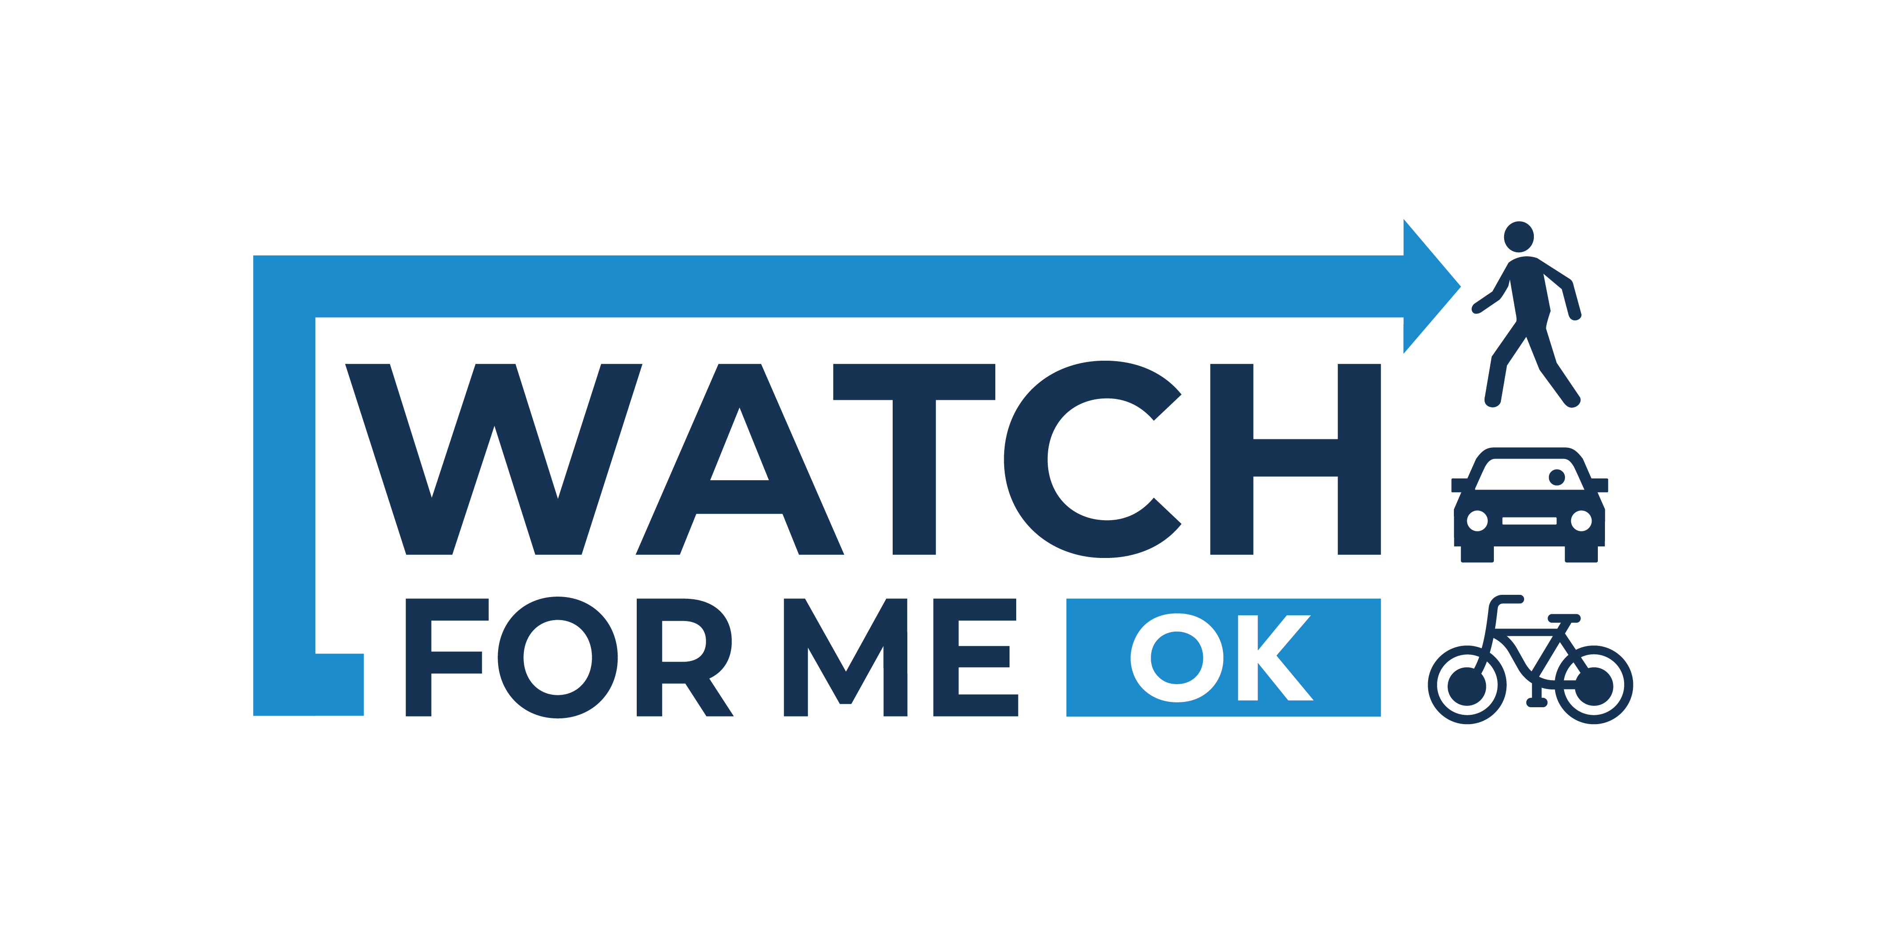
Watch for Me OK Drives Safety Forward in [Insert Town Name]

Central Oklahoma is growing – with more bicyclists, pedestrians and drivers on the roads, safety has become a growing concern. The Association of Central Oklahoma Governments (ACOG) is partnering with the Oklahoma Highway Safety Office (OHSO) and City of Oklahoma City to increase the overall visibility of pedestrian and bicyclist safety issues and make Oklahoma a better place to walk, bike and drive with the launch of Watch for Me OK. This public awareness campaign is designed to reduce the total number of pedestrian and bicycle crashes and fatalities in [insert town name] and across Central Oklahoma.

[Insert a quote from your mayor, city official, or community leader. Could focus how this campaign makes them feel safer or how they see this benefitting the community. If you have a local bike or runners club, this would also be a great place to highlight their perspective on this campaign.]

According to the Oklahoma Highway Safety Office, bicyclist- and pedestrian-involved crashes and fatalities have steadily increased over the past ten years in Oklahoma. Watch for Me OK aims to reduce the number of crashes by sharing safety messages and educating motorists, bicyclists and pedestrians on the rules of the road.

“As a community, we must learn to move together safely,” said Mark W. Sweeney, AICP, Executive Director of ACOG. “We have a responsibility to keep ourselves and each other safe, and together we can reduce accidents while continuing to enjoy all modes of transportation.”

By looking out for each other, this campaign will help change Oklahoma’s standing as the 14th most dangerous state for pedestrians. And no matter how pedestrians, bicyclists, and drivers get around [insert town name], they’ll be using best practices to keep everyone safe.

[Optional: Insert another quote from a city official or community leader. Include any details on how your town will be supporting Watch for Me OK, such as handing out copies of the Watch for Me OK coloring page at your local municipality, school or library.]

To learn more about the Watch for Me OK campaign or to find messages, materials, and more safety information, visit www.watchformeok.org. You can also connect with the campaign on Facebook, Instagram and Twitter @watch4meok.

###

Watch for Me OK is a public awareness campaign from The Association of Central Oklahoma Governments, the city of Oklahoma City and The Oklahoma Highway Safety Office with the goal of reducing the number of pedestrian and bicycle crashes and fatalities in central Oklahoma. The campaign seeks to educate the public on the rules of the road and aims to keep residents safe while traveling. The program aims to reach people through public service messages, community engagement efforts, educational materials and partnerships with area leaders such as government staff, pedestrian and bicycle advocates, city planners, law enforcement agencies, engineers, public health professionals, the media, influencers, elected officials, parents and educators. Learn more at www.watchformeok.org.

